**How To Setup A Trust To From A Blue Forest to the Equifax Red Forest. (GUI)**

1. Open Active Directory Domains and Trusts

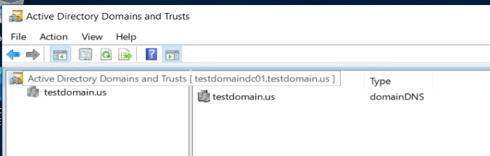

1. Right click your domain select properties

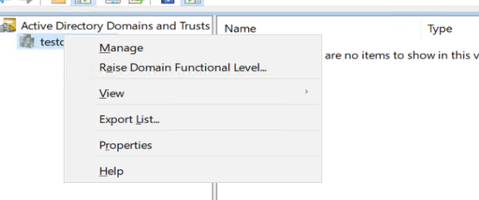

1. Select the Trust tab

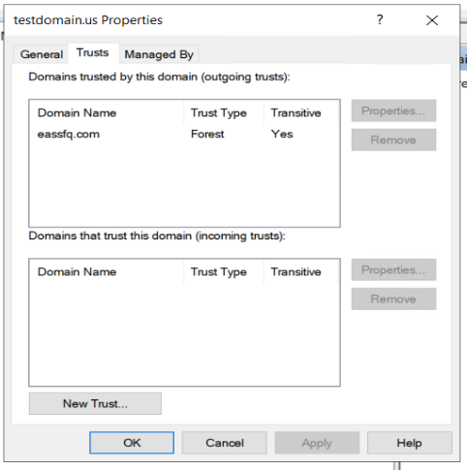

1. Click New Trust then click Next

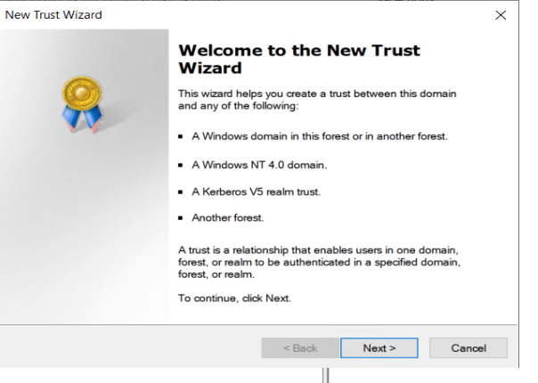

1. Enter Destination Domain

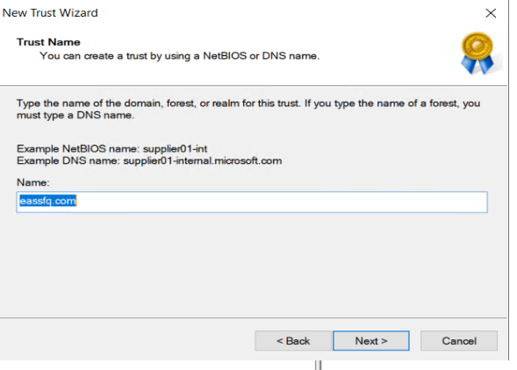

1. Enter username and password for resource domain

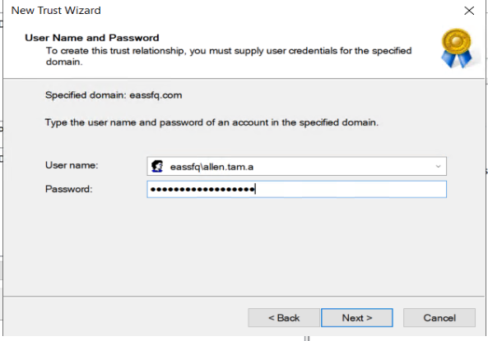

1. Select Forest Trust

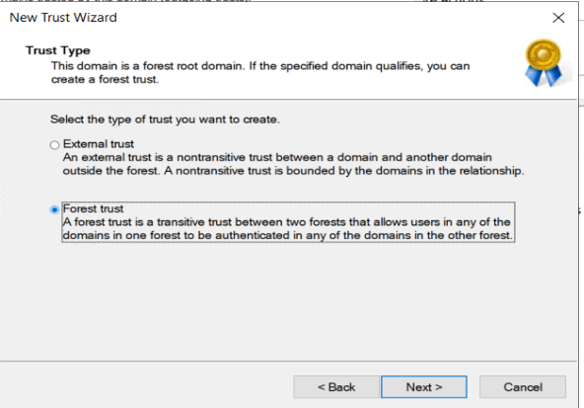

1. Select One-Way Outgoing Trust

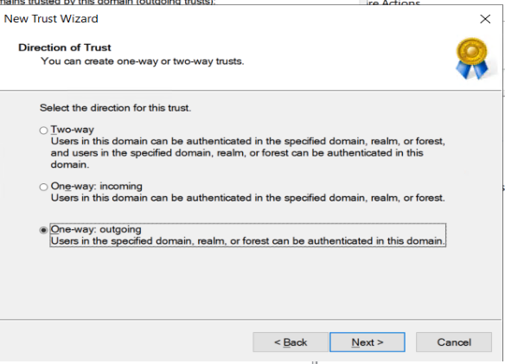

1. Select Both this domain and the specified domain.

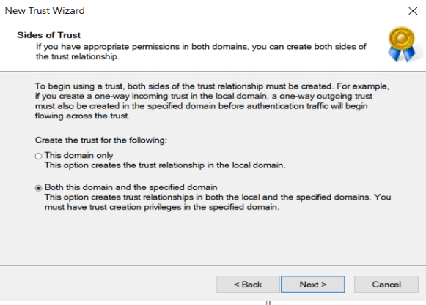

1. Enter admin username and password

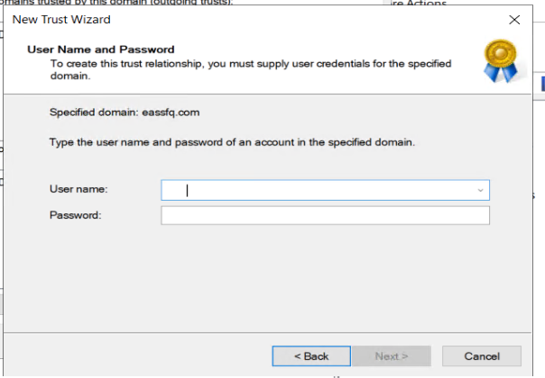

1. Select Forest-wide Authentication

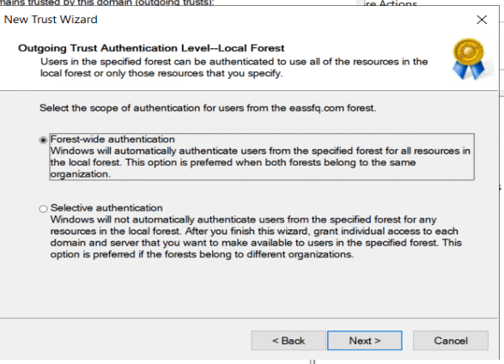

1. Selet next

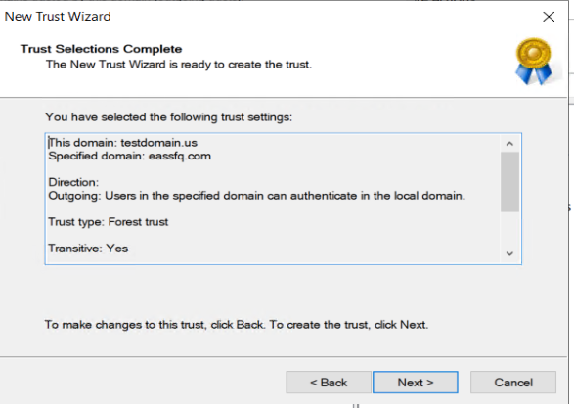

1. Select Next Again

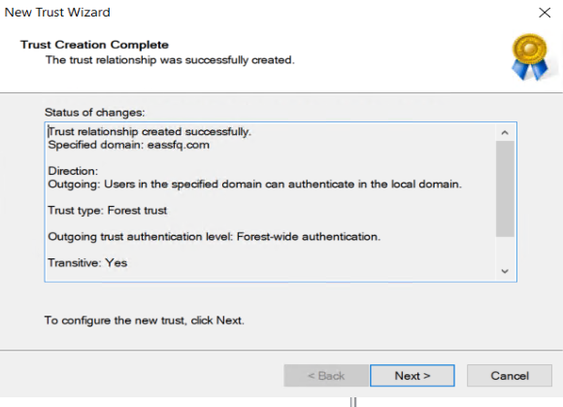

1. Click yes Confirm the outgoing trust

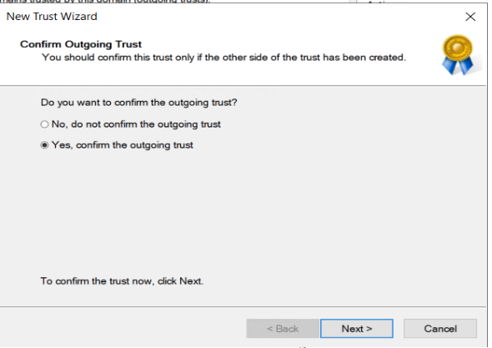

1. Click Finish

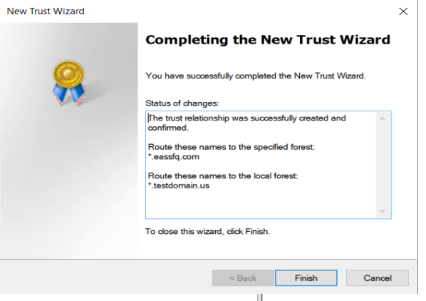

17. The Trust should show up as pictured below with Transivity Yes.

